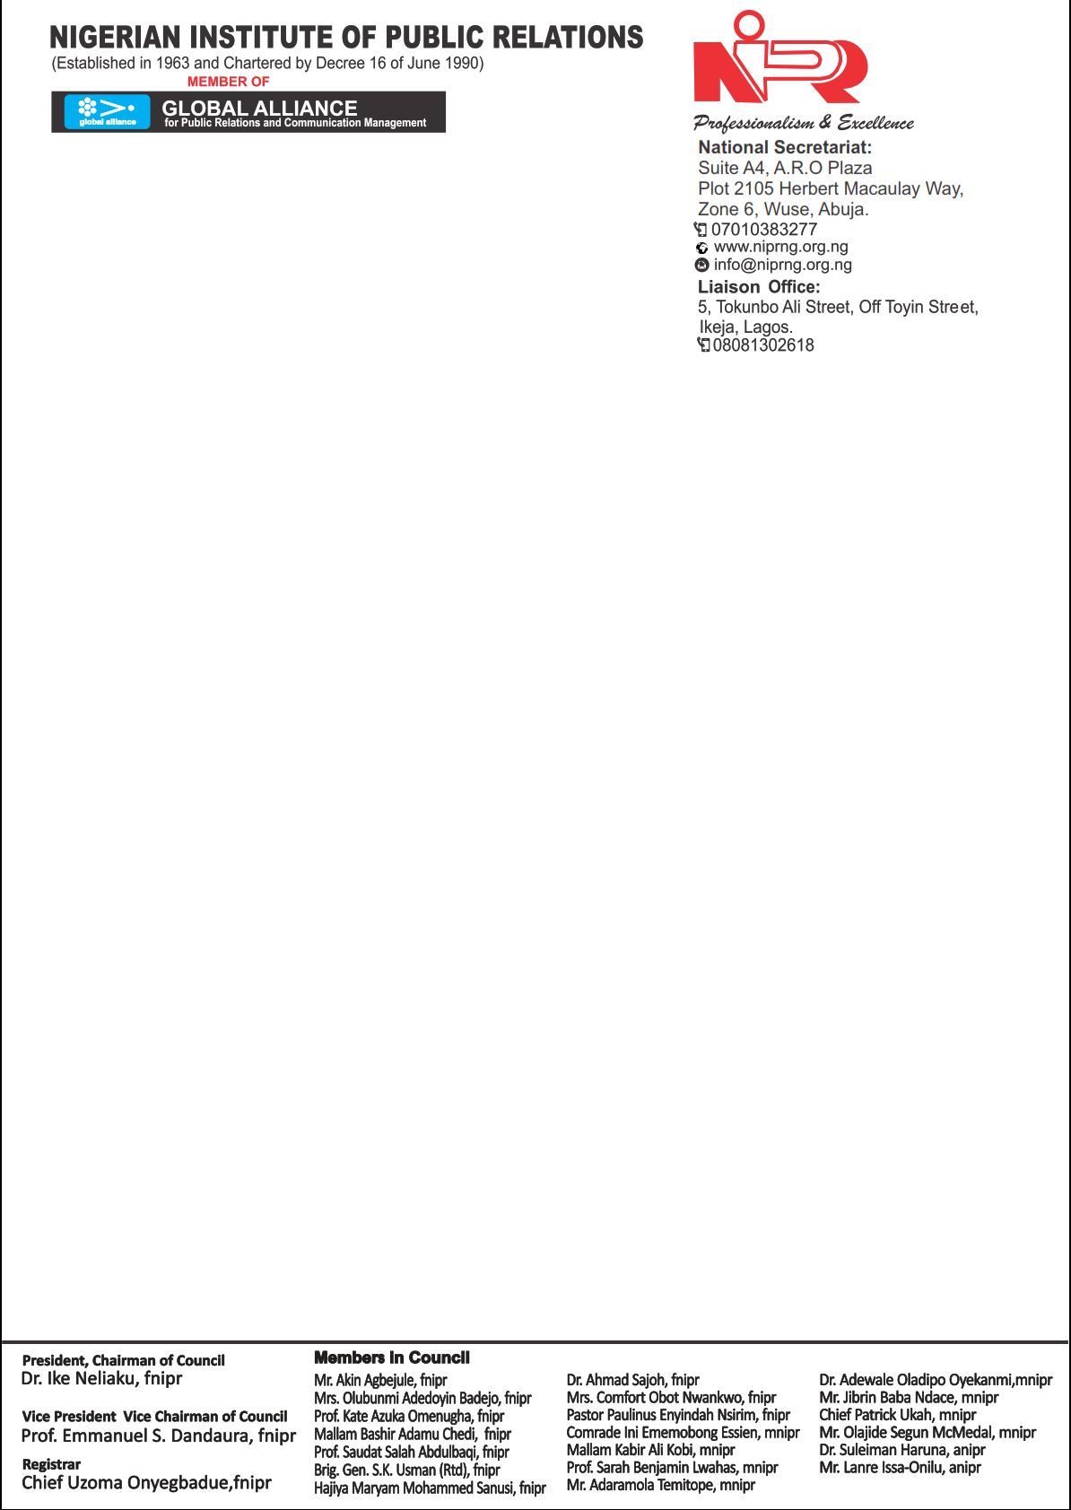
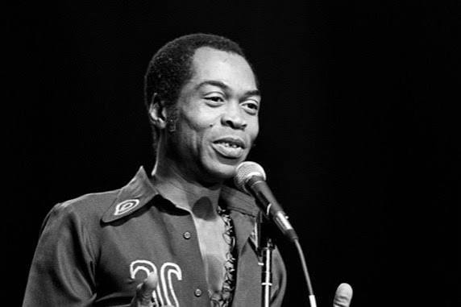

FELA’S GRAMMY AWARD REAFFIRMS CULTURE AS NIGERIA’S GREATEST REPUTATIONAL DRIVER - NIPR
The Nigerian Institute of Public Relations (NIPR) has hailed the posthumous Grammy Lifetime Achievement Award conferred on Afrobeat legend Fela Anikulapo Kuti as a monumental boost to Nigeria’s global reputation. The Institute says the recognition reinforces findings from the Nigeria Reputation Perception Index (NRPI) Report 2025, which identifies culture as the nation’s most powerful reputation asset.
According to the NRPI 2025 Report, which assessed Nigeria’s reputation across seven pillars, Leadership, Performance, Credibility, Communication, Innovation, Social Equity, and Culture, culture remains the most resilient driver of Nigeria’s global visibility. While the country’s overall reputation perception score stands at 35.2 per cent, reflecting moderate awareness but weak trust conversion, the cultural sector continues to project Nigeria’s identity and creativity with unmatched influence.
Reacting to the award, the Acting President of NIPR and Chairman of the NRPI Board, Prof. Emmanuel Dandaura, stated:
“Fela’s Grammy Lifetime Achievement Award is more than a personal honour; it is proof that Nigeria’s cultural heritage is the country’s most effective tool for positive nation branding. The NRPI 2025 Report, based on responses from 3,911 participants across all 36 states, the FCT, and key global regions, confirms that while governance-related pillars show trust deficits, culture consistently enhances Nigeria’s global reputation.”
Prof. Dandaura noted that beyond Fela’s enduring global impact, contemporary icons such as Burna Boy, Davido, Wizkid, Tems, Tiwa Savage, and Tobi Amusan, alongside creators in film, fashion, and design, continue to affirm Nigeria’s cultural dominance and soft-power leadership.
“From music to movies, sports to fashion, Nigerian talent is shaping global conversations and redefining how the world sees us,” he said. “Culture is not merely entertainment, it is economic diplomacy, reputation capital, and the strongest lever for repositioning Nigeria’s image before the international community.”
The NIPR congratulates the Anikulapo-Kuti family and all Nigerians, affirming that this Grammy belongs to the nation.
For access to the full NRPI 2025 Report, visit https://rpireport.com



Duke Imandu
Ag. Director, Public Relations
02-02-2026
